**Batch:B2-2/H2_1 Roll No:-16010122151**

**Experiment 05**

|  |
| --- |
| **Title: Working with time-series data.** |

# Objective:

# *Search/locate and download the time series Data*

# *To learn how to visualize time series data*

# *Applying trend line over visualized time series data using analytics options*

# *Perform forecast over the time series using analytics options*

# Course Outcome:

# CO1: Learn how to locate and download datasets, extract insights from that data and present their findings in a variety of different formats.

# CO3 Apply data visualization best practices

# Books/ Journals/ Websites referred:- 1) https://boralot.com/ -websites/

# Resources used:- 1)https://www.youtube.com/watch?v=6tklXV-Hh24.

# Theory:

# Definition Time series:

(Theory related to experiment needed to perform - Students should write)

# Following points should be written by students

# Observation after plotting of time series data

# Observation after plotting trend line (Linear, Exponential and polynomial)

# Observation after Forecast (Automatic, Additive, and multiplicative, along with season options)

# Note: Detail observation needed along screenshots wherever required

# 1)

# 2)

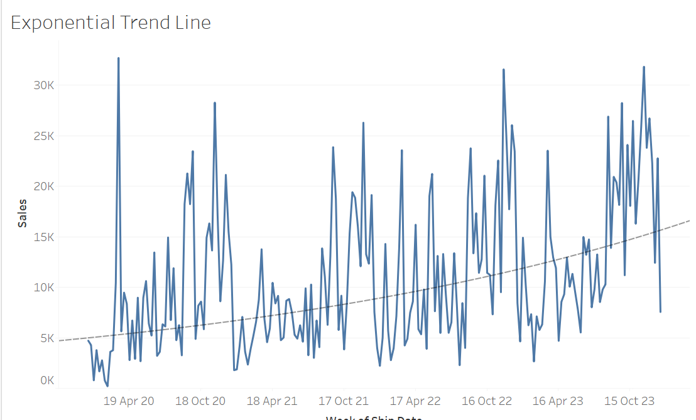

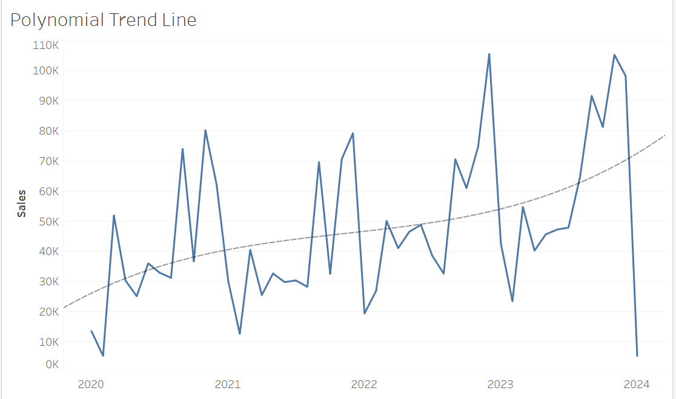

**a)Linear Trend Line:-**

1)A linear trend line works well for data that forms a straight line. It shows how strong and which way things are connected.

2)If data points are close to the line, they have a strong connection. If they're far away, the connection is weak.

**b)Exponential Trend Line:-**

1)This trend line is for data that quickly goes up or down, like things growing or shrinking a lot.

2)As you move away from the start, data points spread out, showing the fast growth or decrease.

**c)Polynomial Trend Line:-**

1)A polynomial trend line suits data with complex, non-straight patterns. How much it curves depends on the data and the chosen degree (like linear, quadratic, etc.).

2)You'll see the line bending to better match the data shape. Picking the right degree is important to fit the data without making it too complicated.

# 3)

# 

# 

# 

# Conclusion (Students should write in their own words, comparative conclusion needed):- The choice between additive and multiplicative forecasting depends on the relationship between trend and seasonality in your data.

# If your automatic forecast aligns well with the observed data, it suggests that the chosen model is appropriate.

# Consider the seasonality options to account for periodic patterns in your data.

# Compare the accuracy of different forecasting methods and select the one that provides the best fit for your time series data.

# Regularly update and validate your forecasts to ensure their accuracy and usefulness in decision-making.

**Date:-17/11/2023 Signature of faculty in-charge**

# Post Lab Question:- Q) Compare the additive and multiplicative model of time series. Ans)Additive Model:-

# Characteristics:- Assumes that the components are additive, meaning that the variations in the time series are added together. Suitable when the seasonal fluctuations have a roughly constant magnitude over time. Often used for data with a relatively constant variance across time.

# Components:- 1)Trend:- Represents the long-term movement or trend in the data.

# 2)Seasonal:- Represents the periodic fluctuations, typically over a year or other fixed period.

# 3)Residual:- Represents random or irregular variations that are not explained by the trend or seasonal components.

# Multiplicative Model:-

# Characteristics:- Assumes that the components are multiplicative, meaning that the variations in the time series are multiplied together. Suitable when the seasonal fluctuations vary in magnitude over time, typically growing or decaying. Often used for data where the variance increases or decreases as the mean value increases.

# Components:- 1)Trend:-Represents the long-term movement or trend in the data.

# 2)Seasonal:-Represents the periodic fluctuations, which are relative to the trend.

# 3)Residual:- Represents random or irregular variations that are not explained by the trend or seasonal components.